**SCHOOL OF ENGINEERING AND TECHNOLOGY**

**ASSIGNMENT / PROJECT SUBMISSION FORM**

**PROGRAMME : BSc (Hons) in Computer Science**

**SEMESTER : Jan / Apr / Aug 2023**

**SUBJECT : WEB1201 / WEB2014 Web Fundamentals**

**DEADLINE : 6July 2023 23:59 MYT**

**INSTRUCTIONS TO CANDIDATES**

* This is a(n) ~~individual~~ / group project.

**IMPORTANT**

# The University requires students to adhere to submission deadlines for any form of assessment. Penalties are applied in relation to unauthorized late submission of work.

# Coursework submitted after the deadline but within 1 week will be accepted for a maximum mark of 40%.

# Work handed in following the extension of 1 week after the original deadline will be regarded as a non-submission and marked zero.

**Lecturer’s Remark** (Use additional sheet if required)

List down the name of the group members and the student IDs here.

**21042692**

**Tham Jian Hao**

I...................................................................................... (Student’s Name) ................... (Student ID) received the assignment and read the comments.

**11/6/2023**



....................................... (Signature/Date)



**Academic Honesty Acknowledgement**

**Tham Jian Hao**

“I .........................................(Student’s Name) verify that this paper contains entirely my own work. I have not consulted with any outside person or materials other than what was specified (an interviewee, for example) in the assignment or the syllabus requirements. Further, I have not copied or inadvertently copied ideas, sentences, or paragraphs from another student. I realize the penalties *(refer to page 16, 5.5, Appendix 2, page 44 of the student handbook diploma and undergraduate programme)* for any kind of copying or collaboration on any assignment.”

**11/6/2023**



….................................. (Student’s signature / Date)

**Lecturer’s Remark** (Use additional sheet if required)

List down the name of the group members and the student IDs here.

**21045596**

**Lim Xiwei**

I...................................................................................... (Student’s Name) ................... (Student ID) received the assignment and read the comments.

**11/6/2023**

............................................ (Signature/Date)

**Academic Honesty Acknowledgement**

**Lim Xiwei**

“I .........................................(Student’s Name) verify that this paper contains entirely my own work. I have not consulted with any outside person or materials other than what was specified (an interviewee, for example) in the assignment or the syllabus requirements. Further, I have not copied or inadvertently copied ideas, sentences, or paragraphs from another student. I realize the penalties *(refer to page 16, 5.5, Appendix 2, page 44 of the student handbook diploma and undergraduate programme)* for any kind of copying or collaboration on any assignment.”

**11/6/2023**

…...................................... (Student’s signature / Date)

**Lecturer’s Remark** (Use additional sheet if required)

List down the name of the group members and the student IDs here.

I...**NG JIA WEN**......... (Student’s Name) **21057146** (Student ID) received the assignment and read the comments.



........................**11/6/2023** (Signature/Date)

**Academic Honesty Acknowledgement**

“I ....**NG JIA WEN**......(Student’s Name) verify that this paper contains entirely my own work. I have not consulted with any outside person or materials other than what was specified (an interviewee, for example) in the assignment or the syllabus requirements. Further, I have not copied or inadvertently copied ideas, sentences, or paragraphs from another student. I realize the penalties *(refer to page 16, 5.5, Appendix 2, page 44 of the student handbook diploma and undergraduate programme)* for any kind of copying or collaboration on any assignment.”



…..............**11/6/2023** (Student’s signature / Date)

**Lecturer’s Remark** (Use additional sheet if required)

List down the name of the group members and the student IDs here.

I...**Ng Zhi-Yi**... (Student’s Name) ...**21053020**... (Student ID) received the assignment and read the comments.

........................11/6/2023............... (Signature/Date)

**Academic Honesty Acknowledgement**

“I ...**Ng Zhi-Yi**...(Student’s Name) verify that this paper contains entirely my own work. I have not consulted with any outside person or materials other than what was specified (an interviewee, for example) in the assignment or the syllabus requirements. Further, I have not copied or inadvertently copied ideas, sentences, or paragraphs from another student. I realize the penalties *(refer to page 16, 5.5, Appendix 2, page 44 of the student handbook diploma and undergraduate programme)* for any kind of copying or collaboration on any assignment.”

…......................11/6/2023............ (Student’s signature / Date)

**Data Protection**

The protection of personal data is an important concern to Sunway University and any personal data collected on this form will be treated in accordance with the Personal Data Protection Notice of the institution.

http://sunway.edu.my/pdpa/notice_english (English version)

http://sunway.edu.my/pdpa/notice_bm (Malay version)

**1. Introduction**

Over the past two decades, K-pop, short for Korean pop music, has become a global cultural phenomenon. Originating from South Korea, K-pop has captivated audiences around the world with its catchy melodies, amazing choreography, and eye-catching music videos. This genre has not only profoundly impacted popular culture and the worldwide entertainment scene but also revolutionized the music industry.

One of the most well-known K-pop acts, Blackpink, has achieved astounding success and contributed significantly to the genre's popularization. Since making their debut in 2016, the four extraordinarily gifted members—Jisoo, Jennie, Rosé, and Lisa—have taken the world by storm. They continue to exceed expectations and break countless records with their unique styles, charismatic personalities, and contagious music.

This website will serve as a virtual biography platform specifically designed to highlight the extraordinary journey and achievements of Blackpink. Our main objective is to offer users a comprehensive overview of the group's history and career, a dedicated space to enjoy and listen to their music, a gallery featuring images and videos from their past events, as well as an opportunity to purchase merchandise.

The scope of our website will include the following sections:

* Home Page: An introduction featuring highlighted content from various sections to captivate users’ interest and encourage further exploration.
* Bio: A detailed account of Blackpink's journey, from their debut to their current status as global icons. Individual member profiles will highlight their backgrounds, talents, and contributions to the group.
* Album: A comprehensive catalogue of Blackpink's albums, singles, and collaborations, accompanied by audio samples or streaming links for fans to listen to their music.
* Gallery: A collection of captivating photos capturing Blackpink's performances, music videos, and behind-the-scenes moments from their events and concerts.
* Merch: A dedicated section where fans can browse and purchase official Blackpink merchandise, including clothing, accessories, albums, and collectibles.

Our chosen theme for the website is to celebrate Blackpink's music and its impact on the world. Bright colours, bold visuals, high-quality imagery, and slick layouts will be used to give users an aesthetically pleasing and engaging experience. The tone will be cheerful and lively, aptly capturing the group's energetic and fun-loving nature. Moreover, making sure the website is mobile-compatible will make it easier for users to access it on their smartphones and tablets.

Overall, whether you identify as a devoted Blink (Blackpink's fandom name) or a curious newcomer, this website will serve as your primary destination for all things Blackpink. It is also an excellent place for fans to explore, celebrate, and connect with one of the world's most renowned K-pop groups.

**2. Design Plan**

**2.1 Design**

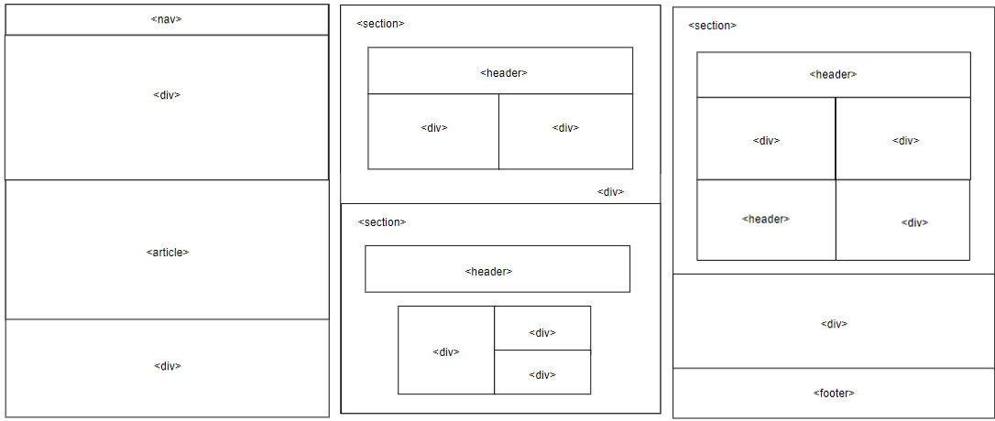

**Figure 1**. Home Page Brief Page Layout

The Home Page sketches feature a top navigation menu for easy access to other sections. A prominent header container is positioned below the menu, accompanied by a visually appealing image. An article section introduces the K-pop group focused on the website. Another division presents an additional captivating image. Three sections represent introductions to other main web pages, with headers and brief content. The Merch page is introduced in a separate "banner" division. A footer section provides links and contact information.

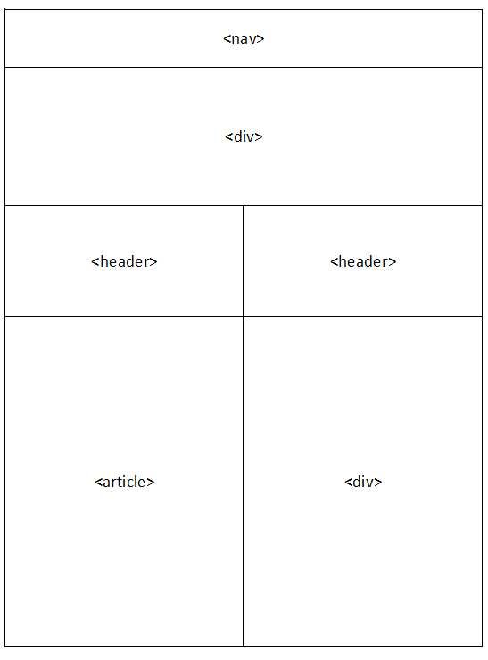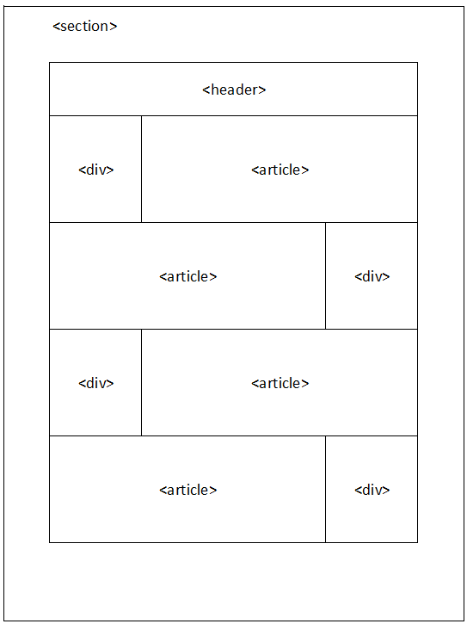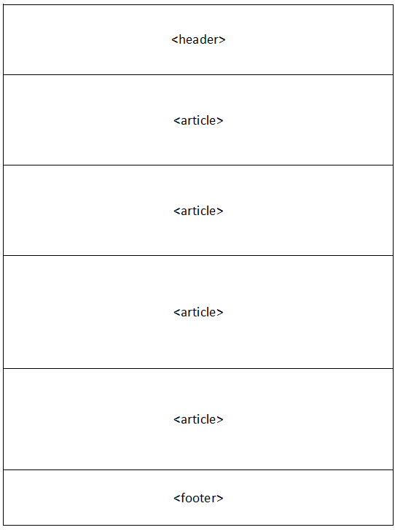



The Bio Page exhibits a navigation bar at the top, followed by an image of the group members. An article and division tag explains the meaning behind the group’s name and their many achievements throughout the years. A section attribute encompasses the group members’ information into smaller and more readable chunks, accompanied by images of the members. The part beneath is dedicated to detailing the history of the group from its debut all the way to the present.

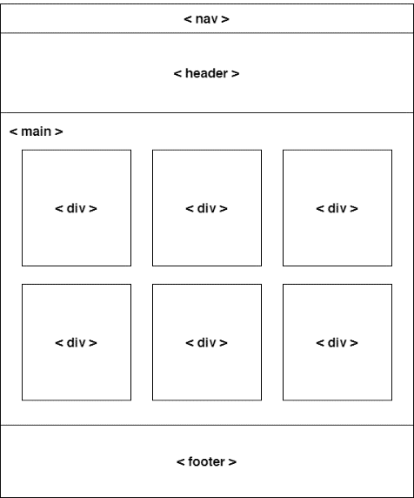

**Figure 3**. Album Page Brief Page Layout

Similar to other pages, the Album Page features a navigation bar, header, and footer for consistency. However, the main distinction lies in the album page's layout. In the album page sketch, the main content area is divided into six distinct divisions with space around them. This design choice allows for a visually pleasing and organized presentation of the album content. Each division can be dedicated to showcasing different albums or providing details about individual albums, such as release year and album cover image.

**Figure 4**. Album Playlist Page Brief Page Layout

The Album Playlist Page sketch maintains consistency with other pages through the inclusion of a navigation bar, header, and footer. It introduces a wrapper to centralize the album cover image, music player interface, and track list in the middle of the page. The album cover and music player divisions are displayed side by side, while the track list is positioned beneath them. This design enhances the user experience by providing easy access to album content and a balanced layout.

**Figure 5**. Gallery Page Brief Page Layout

In keeping with consistency, the Gallery Page maintains the inclusion of a navigation bar, header, and footer, as seen on other pages of the website. To optimize the visual presentation of images, a grid layout will be employed. In addition, a division is created in the middle of the page to display a video element. This design enhances the user experience by providing an intuitive image browsing experience and an engaging video component.

**Figure 6.** Merch Page Brief Page Layout

On the Merch page, a similar navigation bar and footer element is used, keeping to the consistency of the website. On top of that, it will include a toolbar where users can further refine and narrow down their search results. Next, a wrapper will contain a heading that describes the current view of products, followed by a list of products arranged in a grid layout, and several buttons to navigate between pages. The grid layout, featuring three products per row, with a maximum of nine products per page, promotes enhanced visibility and a clear separation of the products.

**Figure 7.** Merch Info Page Brief Page Layout

Similarly, the navigation bar, toolbar, and footer are used in the Merch Info page. This page will be split into two equal sections horizontally. The left section will contain a large preview of the product with relevant views from other angles, while the right section will consist important information about the product, such as its name, price, size, quantity, and product information. This page will facilitate users in adding the particular product to their shopping bag.

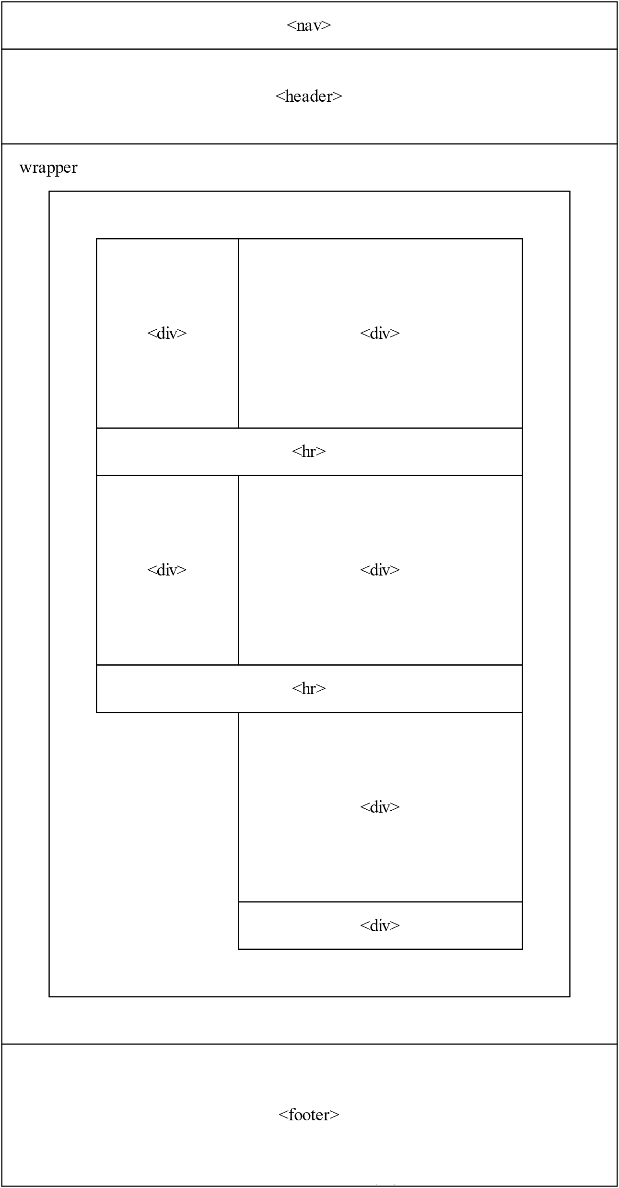

**Figure 8.** Shopping Bag Page Brief Page Layout

Apart from the repeated elements, the Shopping Bag page will utilize a wrapper container to display the list of products that have been added to the shopping bag. Each individual product will be separated by a horizontal line. At the end of the list, the total amount payable by the customer will be clearly displayed, along with a button prompting the customer to proceed to checkout.

**2.2 Colour Scheme**

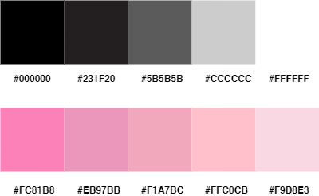

**Figure 9**. Main Colour Palette

Figure 9 shows the main colour palette for our website design plan. The background colour of our website is hex colour #231F20. We select #231F20, a lighter black, as our background colour because, despite producing a very high-value contrast, white text on a pure black background is less readable and causes more eye fatigue. Shades of pink and black are used as our primary colours to align with BLACKPINK's brand image. Along with pink, we have incorporated a light yellow (#FFF7AD) gradient for elements such as the album cover border in the Album page and the scroll-to-top button. The combination of yellow and pink elicits a sense of vibrancy, energy, and positivity, aligning well with the overall theme and tone of our website.

**2.3 Typography**

Open Sans, League Spartan, Arial, and Sanchez are the typefaces we use. Readability was a top priority, as we wanted our content to be easily readable across various devices and screen sizes. To achieve this, we chose Open Sans as our primary typeface for content. Its clean design, combined with ample spacing between letters and appropriate font size, enhances readability and ensures that users can read through the information effortlessly. Aesthetic appeal was another important consideration. We aimed to create a modern and visually engaging website, and therefore, we chose League Spartan for our Heading 1. This bold and stylish font conveys a sense of confidence and captures attention, making it suitable for important headings and titles. For Heading 2, we selected Sanchez, a serif font that adds a touch of elegance and sophistication to our design. We also considered the alignment of the fonts with our website's tone and branding. With its clean and modern look, Open Sans aligns well with the professional aspect of our brand, while League Spartan and Sanchez add a touch of uniqueness and creativity. Although the previously mentioned fonts align with the Blackpink brand's tone and enhance readability, there may be occasions where the content requires a neutral and easily readable typeface that does not distract from the overall design. In such cases, we have utilized Arial to ensure that the text remains clear and legible, providing a seamless reading experience for our users.

**2.4 Organisation**

**Figure 10**. Page hierarchy.

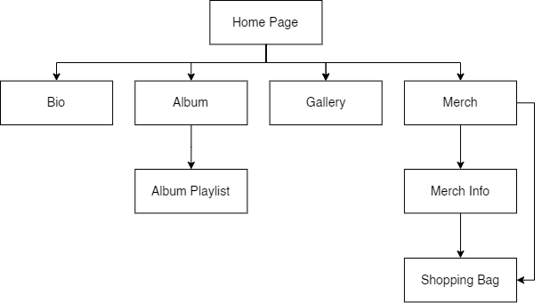

Figure 10 illustrates our website's overall page hierarchy. There are five main pages, including the Home Page, and 3 subpages: album playlist beneath the Album page, merch info and shopping bag beneath the Merch page. Starting with the Home Page, users will find a comprehensive overview of the website's content. This includes brief highlights from the other pages, as well as additional details about upcoming tour dates accompanied by a countdown timer, creating anticipation and excitement. The Bio page is dedicated to profiling the Blackpink K-pop girl group and its talented members. Here, users can learn more about the background, achievements, and unique qualities of each member, providing a deeper understanding of the group's identity and individual contributions. The Album page showcases six popular albums, each represented by an album cover. When users click on an album cover, they will be directed to an album playlist. The playlist contains a complete list of songs included in the respective album, allowing users to enjoy the music and explore the group's discography. Our Gallery page is a visual treat for users, featuring captivating photos taken during their live shows. It provides an immersive experience, giving users a glimpse into the energy and excitement of a Blackpink performance. For fans looking to support the group and show their love, the Merch page displays the official Blackpink merchandise currently available. Each product image is thoughtfully linked to its own merch info page, where users can find detailed descriptions, pricing, and other relevant information. To facilitate the shopping experience, we have included a dedicated Shopping Bag page accessible from both the Merch page and the Merch Info page. This allows users to easily review and manage their selected items before proceeding to the checkout process, ensuring a smooth and convenient shopping journey.

**2.5 Navigation**

The primary navigation bar is placed at the top of each page, providing clear and easily identifiable links to the main sections of our website. These sections include the Home Page, Bio, Album, Gallery, and Merch. While scrolling, the navigation bar on most of our web pages will remain at the top of the page. Users can conveniently locate and navigate to their desired destinations with just a single click. In addition to our primary navigation menu, we have implemented another set of links in the footer of our website. The footer serves as a secondary navigation option, offering quick access to important pages or sections that users may want to explore. Furthermore, we have incorporated a scroll-to-top button, which appears as a discreet icon in the corner of the screen as the user scrolls down the page. This button provides a convenient shortcut for users to instantly return to the top of the page, saving them time and effort. The scroll-to-top button is especially useful for longer pages. It ensures a smooth browsing experience by eliminating the need for manual scrolling to reach the top of the page.

**2.6 Usability**

We have implemented responsive design techniques to optimize the website's display across various devices and screen sizes. The addition of the viewport meta tag:

<meta name="viewport" content="width=device-width, initial-scale=1.0">

allows the website to adapt its dimensions and scaling to different browsers. This ensures that the content remains accessible and visually appealing, regardless of the device being used. To enhance responsiveness further, we utilize percentage values for image widths, enabling them to scale proportionally based on the browser size. The "vw" unit is employed when setting text sizes, allowing the text to adjust dynamically with the browser window. By employing media queries, we design and tailor the layout for different breakpoints, ensuring optimal viewing experiences for desktop displays (1280px - 1920px), mobile displays (360px - 414px), and tablet displays (601px - 1280px).

Accessibility is also a priority in our design approach. We utilize the alt attribute to provide alternative text descriptions for images. This descriptive text conveys the image's purpose or content, allowing visually impaired users or those with image-loading issues to understand the context. Additionally, screen readers utilize the alt attribute to read aloud the image descriptions, making the website more accessible to all users.

Furthermore, we employ both a background colour and a background image to enhance the visual experience. The background colour ensures sufficient contrast with the text, even if the background image fails to load. This ensures that the content remains legible and user-friendly in any scenario, providing a seamless browsing experience for all visitors.

**2.7 Content**

The navigation bar, footer, and scrollbar have been designed to maintain consistency throughout all web pages.

**Figure 11**. Nav Bar and Scrollbar Design

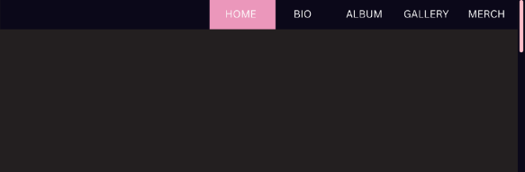

Implementing the <nav> element, our navigation bar boasts a clean and straightforward design, featuring links (<a> elements) with names that correspond to their respective destination pages. Both the navigation bar and hyperlinks are adorned with a sleek background colour of #0B0819. To enhance user experience, the underline in hyperlinks has been removed using the "text-decoration" attribute. When users hover over a link or navigate to a specific page, the background colour of the link changes to #EB97BB. This visual feedback is achieved through the use of the :hover selector and overriding the background colour for an engaging effect. Moreover, to ensure compatibility across different browsers, we have incorporated CSS vendor prefixes, such as "-webkit-" for Chrome, "-ms-" for Microsoft Edge, and "-moz-" for Firefox, to customize the scrollbar. Customizing the scrollbar allows us to add a personal touch and maintain a consistent aesthetic throughout the website.

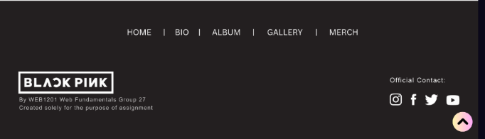

**Figure 12**. Footer Design

Our footer section follows a more streamlined design, featuring a set of links elegantly separated by "|". On the left side of the footer, we display the iconic Blackpink logo, accompanied by information about its creator and purpose. Additionally, we have placed social media icons in the right corner of the footer, providing users with convenient access to each app's official account. Through the thoughtful arrangement of text and graphics using the float attribute, the footer exudes a visually appealing and balanced composition. To enhance navigation efficiency, we have implemented a scroll-to-top button that dynamically appears as users scroll down a predetermined distance. This fixed button intuitively follows the user's scrolling, allowing for effortless navigation and a seamless browsing experience. The gradient colour used for the scroll-to-top button enhances its visual appeal and grabs attention. By incorporating a gradient colour, the button gains depth and dimension, making it visually engaging. This design decision aims to motivate users to interact with the button, facilitating easy navigation to the top of the page.

In the following sections, we will explore and discuss the various design elements that may be utilized on our web pages.

**2.7.1 Home Page**

**Figure 13**. Home Page Design Plan

On the home page, a division is implemented, and an image is embedded using the <img> element. Within the <article> section, the term "BLACKPINK" is presented in a vibrant pink colour (#EB97BB) with a font size larger than Heading 1, emphasizing the prominence of the group's name. The line "BLACKPINK IN YOUR AREA" is designated as Heading 2 within this section, creating a clear visual hierarchy. The accompanying paragraph provides a brief introduction of the group. To visually separate the heading from the accompanying paragraph, the use of the Float attribute ensures proper alignment. Additionally, the application of bottom padding and a white right border for Heading 2 further emphasize the visual distinction between the heading and the paragraph. To provide users with additional information, the term "More" is incorporated as a link using the <link> element, redirecting users to the relevant web page. Another division is employed to contain an additional image, contributing to the overall visual presentation.

These design choices not only enhance the aesthetic appeal of the content but also provides a clear and engaging introduction to the group for website visitors. The vibrant pink colour and larger font size highlight the significance of the BLACKPINK name, while the use of headings and paragraphs with proper alignment ensures a clear and organized presentation of information. The inclusion of links and additional visuals offers users the opportunity to explore more content and engage further with the website.

**Figure 14**. Home Page Design Plan

The section labelled "Albums" is prominently displayed with a Heading 1 in white text on a pink background, creating a visually appealing title. The descriptive Heading 2 provides additional context and information about the section. To showcase the album images, two divisions are used, each featuring a play button and a share button. The overlapping effect of these buttons is achieved by using CSS attributes such as "position" and "top," creating a visually dynamic and interactive element for users.

To ensure a clean and uncluttered design, only the two most popular album tracks are showcased, allowing users to focus on the key content without overwhelming them with excessive information. The track names are displayed below the album images, providing clear and concise information about each track.

The share button offers users the ability to easily share their favourite music with others, promoting social engagement and interaction. On the other hand, the play button allows users to listen to the selected track with a simple click, enhancing the user experience and providing immediate access to the desired content. A "More" button is provided, offering users the option to explore additional album tracks or content beyond the initial display.

In the third section titled "Gallery," three captivating photos from Blackpink concerts are displayed. The grid layout arrangement provides an organized and visually appealing presentation of the photographs. By clicking the "More" button located at the bottom right of the "Gallery" section, users can access additional photographs, allowing them to delve deeper into the visual experience of Blackpink's live performances.

**Figure 15**. Home Page Design Plan

The third section on the home page is prominently identified by a Heading 1 titled "Upcoming Tours," immediately indicating the content that follows. The descriptive Heading 2 provides further context and information about the upcoming tours.

To enhance visual hierarchy and readability, the phrases "Date" and "Country/Venue" are highlighted in pink (#EB97BB), while the content underneath them, which aims to inform users about Blackpink's schedule, is displayed in white. This contrast ensures that the important information stands out and is easily distinguishable.

For organizing the schedule information, different layout options, such as just simply using 2 division or grid layout or table. can be considered. By utilizing the "border" attribute, a line can be created between the two columns, "Date" and "Country/Venue", providing a clear separation and improving readability. The text under the "Date" column can be aligned to the right, while the text under the "Country/Venue" column can be aligned to the centre, ensuring a balanced and visually pleasing presentation of the information. To distinguish the country name from the venue name in the "Country/Venue" column, the <span> tag can be utilized, allowing for selective styling. By bolding the country name, it becomes more prominent and easier to identify.

To create a sense of excitement and anticipation, a countdown timer is included in this section. The countdown timer, labelled in the same style as the section headers, indicates the time remaining until the upcoming event begins. The timer is designed to count down in days, hours, minutes, and seconds, with each unit displayed as a two-digit value clearly labelled to represent its respective time unit.

In the final part of the home page, a division holding an image is overlapped by another transparent pink gradient background division. This effect is achieved by using the linear-gradient() function and RGBA values, creating an eye-catching and visually appealing design. This effect's purpose is to make the text's colour stand out against the background. The semi-transparent division includes information about the merch web page, enticing users to explore and learn more about the available merchandise. To facilitate user engagement, a "Shop now" link is provided, redirecting users to the merch web page when clicked.

**2.7.2 Bio**

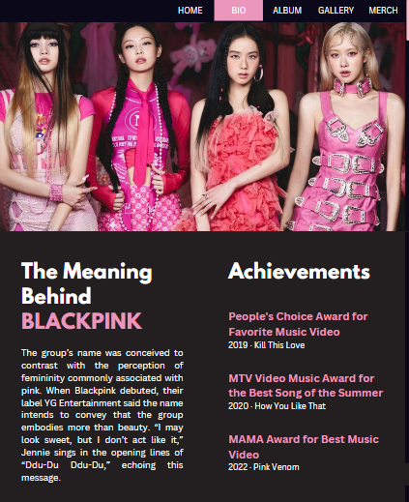

**Figure 16**. Bio Design Plan

The page starts off with a <div> tag containing the image of the members of Blackpink. Two headers are located on the left and right of the page. Heading 1 states "The Meaning Behind BLACKPINK" with a <span> tag to allow the word "BLACKPINK" to be displayed in their signature pink colour. Below it, an informative <article> tag explains the reasons behind the adoption of the name. Beside Heading 1 is another Heading 1with a short and simple "Achievements" text. Underneath it sits 3 of the group’s greatest successes so far. To improve readability the padding attribute is used to space out the two headings and its content evenly.

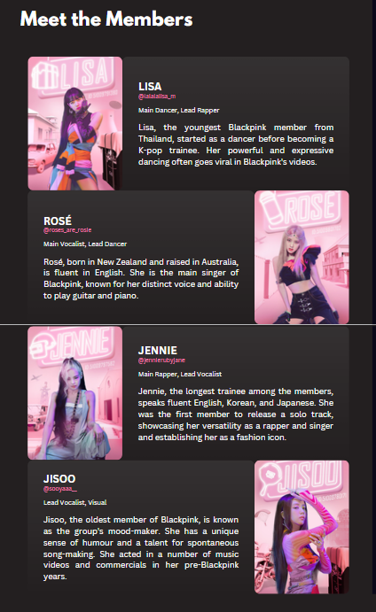

**Figure 17**. Bio Design Plan

Moving on to the members’ introduction, it is contained inside a <section> tag to make the content appear tidier. Blackpink consists of four members, each having their own descriptions and accompanied by a picture of themselves in the section.

Within the section, a Heading 1 titled "Meet the Members" is apparent. The phrase is written in white to better contrast with the black background of the page. Immediately after the heading lies the member information arranged in a zig zag order to make the page visually appealing. The first and third member to be featured in the section, Lisa, and Jennie, has their pictures displayed on the left, and their information on the right, whereas the second and fourth member, Rosé, and Jisoo, have their pictures displayed to the right, and their information presented on the left.

Among the information displayed include, but not limited to, their names, contacts in the form of their Instagram handle, and their roles in the group, which are all contained in the <article> tag. The members’ names are all written in capital letters and are in white, like their roles and information, apart from their Instagram handle, which are listed down in pink. When users click on their Instagram handle, it will redirect them to the member’s Instagram page, thanks to the <link> element.

**Figure 18**. Bio Design Plan

The third section of the bio provides an overview of the group's history, encompassing their debut and future. The title, "The History of BLACKPINK," is styled as Heading 1, with the word "BLACKPINK" displayed in pink and the remaining text in white. Each historical period is represented by four <article> tags, containing a <h2> tag and its corresponding content in a <p> tag. The <article> tags are organized chronologically, spanning two-year intervals starting from 2016-2017, and each stage in the group's journey is covered. To emphasize the importance of the timeline, the years are presented in a darker shade of pink.

**2.7.3 Album**

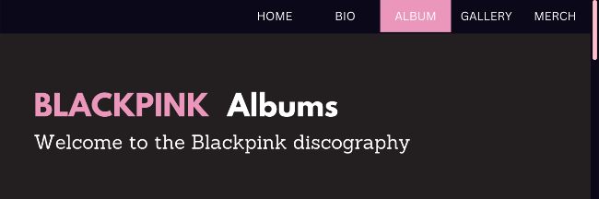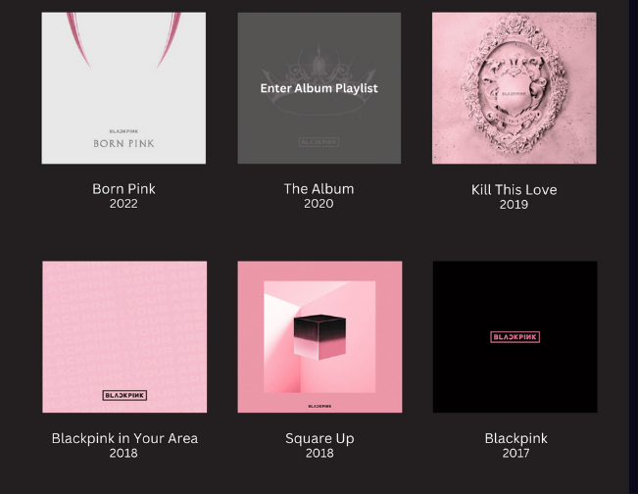

**Figure 19**. Album Design Plan

The header consists of a Heading 1, which incorporates a span tag to highlight the word "BLACKPINK" in a vibrant pink colour (#EB97BB). The Heading 2 complements the main heading and provides additional context. To enhance the visual appeal and spacing of the headings, the padding attribute is utilized to add spaces around them. This ensures that the headings have sufficient room and stand out prominently within the header container.

Moving on to the main container, it consists of six individual divisions, each serving as a container for an album image and its accompanying details, such as the album name and year of release. The album images are made clickable by enclosing the <img> tag within anchor tags, effectively creating image links that direct users to the respective album's playlist page.

To provide visual cues and indicate that the album images are clickable, an image hover overlay effect is implemented. When users hover over an album image, the image opacity decreases, creating a subtle visual change to signify interactivity. Simultaneously, a child division, labelled as Child1, becomes visible, displaying the text "Enter album playlist", providing clear instructions to users. Child1 acts as the parent division to another child division, labelled as Child2. This nesting allows Child2 to be positioned at 50% from the top and left of the parent, aligning its centre with Child1's centre using the "transform: translate(x, y)" property. Initially, Child1's opacity is set to 0, ensuring that the text remains hidden until the user interacts with the album image. The smooth transition between opacity values is achieved using the "transition" attribute.

To maintain a well-organized layout within the main container, the division containers are arranged using flexbox. Flexbox provides a flexible and responsive layout structure, allowing the divisions to adapt to different screen sizes and orientations, ensuring consistent alignment and spacing.

**2.7.4 Album Playlist**

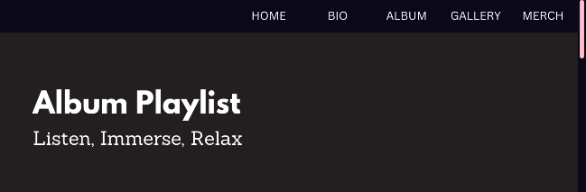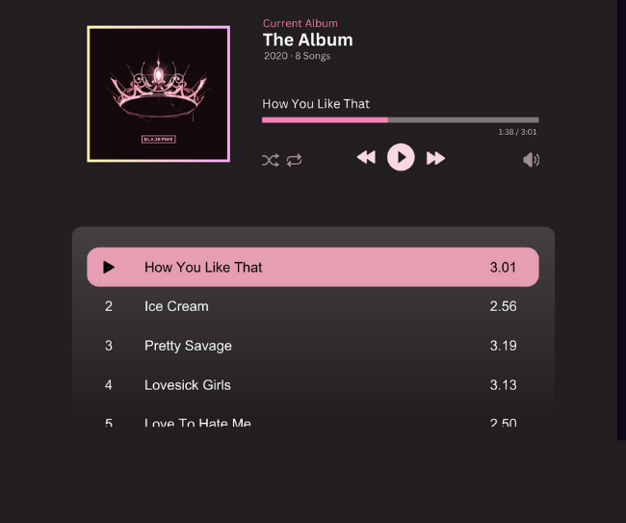

**Figure 20**. Album Playlist Design Plan

The header container consists of two headings that provide essential information and set the context for the content that follows. To create a cantered layout for the album image, music player interface, and song list, a wrapper container is utilized. The divisions containing the album image and the music player interface are displayed as inline blocks, ensuring they align horizontally. On the other hand, the division holding the song list is displayed as a block.

To add a visually striking effect to the album image, a gradient border is created using the border-image and border-image-slice attributes. The linear-gradient() function is employed to generate the gradient effect, enhancing the overall visual presentation of the album image.

Within the music player interface, the <span> element is employed to modify the colour, font size, and opacity of the text. This allows for clear and visually distinct information, including the current album, year of release, total number of songs in the album, name of the currently loaded song, and the progress and total duration of the song.

To provide a user-friendly and interactive experience, a range slider is implemented using the range type <input> tag. The slider is customized using vendor prefixes such as -webkit-slider-thumb, enabling users to manually adjust the progress of the song. Additionally, image buttons are utilized for icons such as shuffle, loop, volume, play, play forward, and play backward. The opacity of the shuffle, loop, and volume buttons is reduced to differentiate them from the play, play forward and play backward buttons, ensuring a clear visual hierarchy.

Text and visuals within the music player interface are arranged using float and flexbox, allowing for flexible and responsive layouts that adapt to different screen sizes and orientations. In the bottom division, the tracks from the current album are listed. The division itself features a transparent white background, creating a fading effect to indicate scrollable division to the user. The "overflow: auto" property is used to make the division scrollable when necessary. To maintain a clean and seamless appearance, the scrollbar of the division is hidden using vendor prefixes and setting its width to 0.

Within the song list, the song titles are presented as a group of buttons, each featuring an image icon or track number, the song name, and the total duration of the song. Flexbox is employed to arrange the contents inside the buttons. Proper spacing is ensured by adjusting the margin and padding properties. The careful consideration of visual details and layout techniques ensures a cohesive and visually appealing presentation of the album and song information, ultimately enhancing the overall user experience on the website.

**2.7.5 Gallery**

**Figure 21**. Gallery Design Plan

At the top of the page, there is a header container adorned with a Heading 1 that states "Gallery." The heading stands out prominently in white, creating a pleasing contrast against the background. A descriptive Heading 2 is incorporated into the header to further enhance its appeal.

The gallery page consists of five divisions, each serving as a container to embed captivating images of Blackpink concerts. The utilization of <div> tags allow for flexible styling and positioning of the images, ensuring a visually pleasing and responsive layout. To achieve a dynamic and engaging user experience, the images are arranged using the display attribute, such as a grid layout. This layout provides a structured and organized presentation of the images, allowing users to easily navigate through the concert visuals.

Furthermore, to provide an immersive multimedia experience, an additional division is created to showcasing a live concert video of Blackpink. By employing the <iframe> tag, the YouTube video content can be smoothly integrated into the webpage, preserving the original quality and functionality of the video player.

When a user clicks on the thumbnail image of the video, the video initiates playback, instantly immersing the viewer in the captivating performance of Blackpink. This intuitive and engaging design choice not only engages user interaction but also enables them to enjoy the concert video content effortlessly.

To achieve the most favourable arrangement and placement of both images and video, attributes such as “display: block” will be used. By harnessing these design elements, the gallery section can effectively present Blackpink's exhilarating concerts, and create an immersive and visually appealing experience for visitors.

**2.7.6 Merch**

**Figure 22.** Merch Design Plan

The merch section of the webpage begins with an image enclosed within a <header> tag at the top, strategically creating a buffer between the navigation bar and the rest of the content. Moving down, a division container acts as a toolbar, offering users multiple options for navigating and customizing their shopping experience.

Inside the toolbar, there is a filter button that launches a slide-in pop-up when pressed. Users can easily filter through the products by using the pop-up’s different filters, such as categories and price ranges. This allows them to refine their search and find products that correspond to their specific preferences. Next, a currency dropdown menu is located across the filter button, where users can select their preferred currency from a list of major world currencies to view the pricing of the products. This feature caters to an international audience, making the shopping experience more convenient and accessible.

Additionally, a search bar is incorporated into the toolbar. By clicking on the search icon, users can activate the search functionality and quickly search for specific items within the store. This feature enables quick access to desired products without having to navigate through numerous pages manually. The toolbar also includes a shopping bag icon that serves as a hyperlink to the shopping bag webpage, where users can review and manage their selected items. The convenient and prominent placement of the shopping bag icon ensures that users can effortlessly access and keep track of their purchases.

Moving on to the main section of the webpage, a parent <main> tag encompasses the entire section, providing a clear structure. Within this section, an <h1> tag is present to display the current view based on the filter results. For example, it may show headings such as "All Products," "Apparel," "Music," or other relevant categories, allowing users to easily identify the displayed products.

The individual product views are presented in a grid layout. Each product is contained within a <div> tag and split into two distinct portions: the upper and lower sections. The upper portion showcases an image of the product against a clean white background, emphasizing the visual appeal of the merchandise. The lower portion, positioned below the image, provides essential information such as the name and price of the product. This information is presented on a light pink (#FFC0CB) background, ensuring clear visibility and contrast.

When users hover over a product view, it enlarges slightly to indicate that it can be clicked for further exploration. Clicking on a product view will redirect users to a dedicated merchandise information webpage, offering more information about the product.

To facilitate seamless navigation through multiple pages of merchandise, a separate <div> element is included as a manual page scroller. This feature allows users to view subsequent pages of products if the initial page does not display all the items based on the search results.

**2.7.7 Merch Info**

**Figure 23.** Merch Info Design Plan

The merchandise information webpage is divided into two sections: a left and right portion. The left section serves as the focal point, featuring a high-quality product image that remains fixed in the middle of the website. This image showcases the product from different angles, allowing users to get a comprehensive view. This feature empowers users to closely examine and inspect the product, enhancing their understanding of its details and quality.

On the right side of the webpage, important product details are presented in a clear and prominent manner. The product name is displayed in uppercase and bold letters and the price is clearly shown, ensuring that vital information is readily available. Below the product name and price, there are input fields provided to facilitate customization. For apparel items, users can easily select their desired size. The selected size is highlighted using a lighter shade of pink (#FFC0CB), ensuring clarity and visual distinction. Additionally, users can specify the quantity of the product they wish to purchase.

To facilitate the purchase process, a large and bold pink button is strategically placed below the size and quantity inputs. The button explicitly prompts users to "Add to Bag," serving as a clear call-to-action that encourages swift and effortless purchasing. For users seeking more in-depth information about the product's features, specifications, and any additional relevant details, they have the option to scroll down the webpage to view the complete list of product information.

**2.7.8 Shopping Bag**

**Figure 24.** Shopping Bag Design Plan

The layout of this webpage is deliberately kept simple and straightforward, ensuring a seamless and transparent transaction experience for all users. At the top of the webpage, a header container provides two essential pieces of information in well-formatted text. The first element is an <h1> tag, boldly stating "Shopping Bag," and directly beneath it, an <h2> tag emphasizes the enticing offer of "Free Shipping & Returns."

Moving further down the webpage, the <main> tag encompasses a white background that serves as a clear canvas for presenting the list of items in the user’s shopping bag. Each item is presented with a concise and informative summary, such as the product image, product name, selected size, unit price, and the quantity ordered.

Every item has two clearly visible options, "Edit" and "Delete." Users who change their mind can modify the item's size using the "Edit" option, or they can delete the item from their bag using the "Delete" option. These options are strategically placed right before the start of the next item to provide consumers control over their selections. Using the <hr> tag, horizontal lines are deliberately added to ensure visual separation between each item. Users may easily discern between items as they check their order thanks to the visual cue provided by these lines.

Towards the end of the list, the total price payable by the user is accurately calculated and presented, taking into account both the subtotal and the shipping cost. This clear presentation ensures that users are fully aware of the final amount they need to pay. To proceed further, a noticeable call-to-action button strategically placed beneath the total price prominently reads "Proceed to Checkout (3)". The number in parentheses indicates the number of items in their order, providing users with a sense of confidence.

**2.8 Challenges Faced**

One of the challenges faced by us was the fact that a team member came from a different practical class than the rest. This discrepancy posed difficulties in collaboration and communication, especially when it came to crucial decisions such as selecting a colour scheme or layout for our website. Despite that, our team managed to overcome this by proactively organizing and scheduling online meetings that accommodated to everyone's availability. This approach encouraged everyone to participate in the decision-making process and to provide constructive and honest feedback to others without the fear of causing offense. As a result, regular meetings were held to keep everyone updated on the latest progress of the assignment.

Another significant challenge we encountered involves selecting a suitable topic for our website. Each team member came up with many excellent ideas; however, only one could be chosen. To address this, we convened as a group to evaluate the merits and drawbacks of each topic, gradually narrowing down our options until we found one that deeply resonated with everyone. This collective deliberation aimed to ensure that all perspectives were thoughtfully considered and acknowledged, resulting in a unified vision among all team members.

**References**

Adricreative. (n.d.). *Magnifying Glass Line Icon*. Canva. <https://www.canva.com/icons/MAEObo_ktqI/>

Ahmatoviq, E. (2019, May 28). *Coachella*. Pinterest. <https://www.pinterest.com/pin/751960469013702038/>

Anderson, S. (2023, March 27). *What are the best screen sizes for responsive web design?* Hobo Web. <https://www.hobo-web.co.uk/best-screen-size/>

andrigraphic. (n.d.). *Setting Outline Icon*. Canva. <https://www.canva.com/icons/MAEj5eC1Y58/>

Auto, H. (2019, December 18). Blackpink fans on warpath after agency fails to release new album from hit Korean girl group. *The Straits Times*. <https://www.straitstimes.com/lifestyle/entertainment/blackpink-fans-on-warpath-after-agency-fails-to-release-new-album-from-hit>

*BLACKPINK | SHOP*. (n.d.). BLACKPINK | SHOP. <https://shop.blackpinkmusic.com/>

*Blackpink 2023 Athletic Puff Print Pullover Hoodie*. (n.d.). BLACKPINK | SHOP. <https://shop.blackpinkmusic.com/products/blackpink-2023-athletic-puff-print-pullover-hoodie>

*BLACKPINK ARENA TOUR 2018 “SPECIAL FINAL IN KYOCERA DOME OSAKA” by BLACKPINK*. (n.d.). Apple Music. <https://music.apple.com/au/album/blackpink-arena-tour-2018-special-final-in-kyocera/1455720702>

*BLACKPINK for Vogue Korea magazine July 2019 issue*. (2023, July 5). Kpopping. <https://kpopping.com/kpics/BLACKPINK-for-Vogue-Korea-magazine-July-2019-issue>

*BLACKPINK Jadi Girl Group K-Pop Pertama yang Puncaki Chart Album di Inggris*. (2022, September 26). <https://hiburan.dreamers.id/article/107581/blackpink-jadi-girl-group-k-pop-pertama-yang-puncaki-chart-album-di-inggris>

*Blackpink Logo and symbol, meaning, history, PNG, brand*. (n.d.). <https://1000logos.net/blackpink-logo/>

*Blackpink, once a novelty, returns to Coachella as the headliner*. (2023, April 16). Blackpink, Once a Novelty, Returns to Coachella as the Headliner | the Peninsula Qatar. <https://thepeninsulaqatar.com/article/16/04/2023/blackpink-once-a-novelty-returns-to-coachella-as-the-headliner>

BLACKPINK. (2023, July 5). *BLACKPINK members kpop profile (2023 updated)*. Kpopping. <https://kpopping.com/profiles/group/BLACKPINK>

*BORN PINK HOODIE*. (n.d.). BLACKPINK | SHOP. <https://shop.blackpinkmusic.com/products/born-pink-hoodie>

*BORN PINK SWEATS*. (n.d.). BLACKPINK | SHOP. <https://shop.blackpinkmusic.com/products/born-pink-sweats>

*BORN PINK Vinyl*. (n.d.). BLACKPINK | SHOP. <https://shop.blackpinkmusic.com/collections/vinyl/products/born-pink-vinyl>

*Fall 23*. (n.d.). Balenciaga. <https://www.balenciaga.com/en-my/new-arrivals/discover/fall-23>

Fandomz, S. M. (2021, June 3). *Ot4 Blackpink Wallpaper💕*. Pinterest. <https://br.pinterest.com/pin/608900812123503112/>

Google Design Icons. (n.d.). *Circle Play*. Canva. <https://www.canva.com/icons/MAA9pxnU8g8/>

Gowman, P., & Gowman, P. (2019). May events 2019 | London Korean Links. *London Korean Links | Covering Things Korean in London and Beyond Since 2006*. <https://londonkoreanlinks.net/2019/05/01/may-events-12/>

*HTML Responsive Web Design (With Examples)*. (n.d.). <https://www.programiz.com/html/responsive-web-design>

Icon54. (n.d.). *Shopping Bag Icon*. Canva. <https://www.canva.com/icons/MADkPxeCmEU/>

Icons8. (n.d.). *Facebook F*. Canva. <https://www.canva.com/icons/MAD2U7VwytM/>

Icons8. (n.d.). *Instagram*. Canva. <https://www.canva.com/icons/MAD2UQat1ys/>

Icons8. (n.d.). *Play Button*. Canva. <https://www.canva.com/icons/MAD2U_FCeCA/>

Icons8. (n.d.). *Repeat*. Canva. <https://www.canva.com/icons/MAB0gojgDCk/>

Icons8. (n.d.). *Shuffle*. Canva. <https://www.canva.com/icons/MADzHF_FAFs/>

igorkrasnoselskyi. (n.d.). *Greater-than Sign Icon*. Canva. <https://www.canva.com/icons/MAETpCk8vr0/>

Jia-Lin. (2020). BLACKPINK look stunning in individual posters for PUBG Mobile game collaboration | allkpop. *Allkpop*. <https://www.allkpop.com/article/2020/09/blackpink-look-stunning-in-individual-posters-for-pubg-mobile-game-collaboration>

*JISOO FIRST SINGLE ALBUM PHOTOBOOK (BLACK)*. (n.d.). BLACKPINK | SHOP. <https://shop.blackpinkmusic.com/collections/jisoo/products/jisoo-first-single-album-photobook-black>

*Jisoo Flower Heart Tote Bag*. (n.d.). BLACKPINK | SHOP. <https://shop.blackpinkmusic.com/products/jisoo-flower-heart-tote-bag>

*Jisoo Me Bucket Hat*. (n.d.). BLACKPINK | SHOP. <https://shop.blackpinkmusic.com/products/jisoo-me-bucket-hat>

KProfiles. (2023, July 3). *BLACKPINK Members Profile (Updated!)*. Kpop Profiles. <https://kprofiles.com/black-pink-members-profile/>

*KRUNK X BLACKPINK In Your Area Pouch*. (n.d.). BLACKPINK | SHOP. <https://shop.blackpinkmusic.com/products/krunk-x-blackpink-in-your-area-pouch>

Leela. (2018, June 16). *BLACKPINKOFFICIAL*. Pinterest. <https://www.pinterest.com/pin/727401777289692846/>

Lier, B. (n.d.). *Fast Forward Button*. Canva. <https://www.canva.com/icons/MAEVl8vnYXQ/>

logosandbrands. (n.d.). *Twitter Logo*. Canva. <https://www.canva.com/icons/MAEVaXfrxlQ/>

Mie.Karl. (2022, October 17). *BLACKPINK 🖤💗*. Pinterest. <https://www.pinterest.com/pin/1101763496315626082/>

Moon, K. (2019, April 4). Everything to Know About K-Pop Group BLACKPINK. *Time*. <https://time.com/5562946/blackpink-k-pop-everything-to-know/>

Natty. (2022, August 7). *JENNIE STAN 😍😍 on Twitter*. Pinterest. <https://www.pinterest.com/pin/663506957616589138/>

Nawicon. (n.d.). Share Line Icon. Canva. <https://www.canva.com/icons/MAEjGrC-r14/>

Nesvig, K. (2023, April 14). The Exclusive BLACKPINK Coachella Merch Is Too Cute. *Teen Vogue*. <https://www.teenvogue.com/story/exclusive-blackpink-coachella-merch>

News, T. (2023, March 23). *Live Nation Taiwan in hot water with Blackpink fans after controversial IG post | Taiwan News | 2023-03-23 15:53:00*. Taiwan News. <https://www.taiwannews.com.tw/en/news/4844434>

*Pantip - Learn, Share & Fun*. (n.d.). <https://pantip.com/topic/39591593>

Rafiico Studio. (n.d.). *Play Button*. Canva. <https://www.canva.com/icons/MAB_hWVYx9A/>

*Refurbished Mac Deals - Apple*. (n.d.). Apple. <https://www.apple.com/shop/refurbished/mac>

RV Designer. (n.d.). *Plus*. Canva. <https://www.canva.com/icons/MAEt_QW2q3o/>

sooyammy. (2020, May 9). *BLACKPINK - KILL THIS LOVE + DON’T KNOW WHAT TO DO (DVD TOKYO DOME 2020)* [Video]. YouTube. <https://www.youtube.com/watch?v=PZ8G_9-dfpM>

*Standard CD*. (n.d.). BLACKPINK | SHOP. <https://shop.blackpinkmusic.com/collections/cd/products/standard-cd>

*Taylor Swift Official Online Store*. (n.d.). Taylor Swift Official Online Store. <https://store.taylorswift.com/>

*The Power-Coupling of K-Pop and the Luxury Sector - BurdaLuxury*. (2022, December 19). BurdaLuxury. <https://www.burdaluxury.com/insights/luxury-insights/k-pop-and-the-luxury-sector/>

*These Are Blackpink's 12 Most Memorable Moments So Far*. (2022, December 2). Vogue Hong Kong. <https://www.voguehk.com/en/article/celebrity/blackpink-milestones/>

Tyzun, V. (2019, May 20). *Web Music App - Player*. Pinterest. <https://www.pinterest.com/pin/414612709444663121/>

*Universal Music Malaysia Online Store*. (n.d.). [https://universalmusicshop.avana.asia/categories/67133#](https://universalmusicshop.avana.asia/categories/67133)

verry-poernomos-images. (n.d.). *Speaker Icon*. Canva. <https://www.canva.com/icons/MAE72Sro3IQ/>

*Website Maker Editor*. (n.d.). Website Maker Editor. <https://www.renderforest.com/website-maker/new/lang/preview-project/template/90?backUrl=websites%2Fmusic>

Wikipedia contributors. (2023). Kill This Love. *Wikipedia*. <https://en.wikipedia.org/wiki/Kill_This_Love>

Wikipedia contributors. (2023a). Blackpink (EP). *Wikipedia*. <https://en.wikipedia.org/wiki/Blackpink_(EP>)

Wikipedia contributors. (2023a). Blackpink in Your Area. *Wikipedia*. <https://en.wikipedia.org/wiki/Blackpink_in_Your_Area>

Wikipedia contributors. (2023b). Born Pink. *Wikipedia*. <https://en.wikipedia.org/wiki/Born_Pink>

Wikipedia contributors. (2023c). The Album (Blackpink album). *Wikipedia*. <https://en.wikipedia.org/wiki/The_Album_(Blackpink_album>)

鄒紫. (2019, August 9). *BLACKPINK - KILL THIS LOVE (ALT 2) by itzyxcx on DeviantArt*. Pinterest. <https://ru.pinterest.com/pin/543246773801715993/>

**Appendix**

MEETING RECORDS

|  |  |  |
| --- | --- | --- |
| **DATE** | **ATTENDED BY** | **ITEM DISCUSSED** |
| **12/06/2023** | Lim Xiwei, Tham Jian Hao, Ng Zhi-Yi, Ng Jia Wen | All team members suggested various topics and voted to finalize the focus topic.  We agreed to consider two options for our website: either as a music player like Spotify or to focus solely on a music artist. |
| **20/06/2023** | Lim Xiwei, Tham Jian Hao, Ng Zhi-Yi, Ng Jia Wen | After careful consideration, we decided to focus our website on a specific music artist.  We decided to use a K-Pop Group called Blackpink as our website's theme.  We collaborated to create an agreed-upon sketch website hierarchy. |
| **21/06/2023** | Lim Xiwei, Tham Jian Hao, Ng Zhi-Yi, Ng Jia Wen | We outlined a comprehensive content plan and design ideas for each webpage of the website.  Tasks were divided among team members as follows:   * Jia Wen will work on the Home Page. * Zhi Yi will handle the Bio and Gallery pages. * Xiwei will take charge of the Album Page. * Jian Hao will be responsible for the Merch Page.   Consensus was reached on using Canva as our design application for the website. |
| **24/06/2023** | Lim Xiwei, Tham Jian Hao, Ng Zhi-Yi, Ng Jia Wen | Discussion held to determine the elements that should maintain consistency throughout the website.  Collaborative design session conducted to establish a consistent design across all pages.  Final decision made regarding the main fonts to be used.  Announcement made to begin the individual design phase.  Deadline set for design phase: 02/07/2023. |
| **28/06/2023** | Lim Xiwei, Tham Jian Hao, Ng Zhi-Yi, Ng Jia Wen | Short meeting held to discuss on the addition of sub webpages, specifically Album Playlist, merch info, and shopping bag. |
| **02/07/2023** | Lim Xiwei, Tham Jian Hao, Ng Zhi-Yi, Ng Jia Wen | Review and feedback session conducted for all team members' design and report content.  Changes and adjustments made based on the feedback received from team members. |

ACTIVITY LOG

|  |  |  |
| --- | --- | --- |
| **DATE** | **PROGRESS** | **RECORDED BY** |
| **07/06/2023** | **Creating a group chat**  Group chat created in MS Teams. | Lim Xiwei |
| **12/06/2023** | **Choosing a website topic**  Discussed potential website topics and decided on music as the main topic. | Tham Jian Hao |
| **20/06/2023** | **Choosing which artist to feature on our website**  Due to its popularity and visually appealing aesthetics, we selected a K-pop group called BLACKPINK. | Tham Jian Hao |
|  | **Determining web pages**  Brainstormed and identified the main web pages to include Home Page, Bio, Album, Gallery, and Merch. |  |
|  | **Picking the colour scheme**  Unanimously decided to use black and pink as the main colours to align with BLACKPINK's brand image. |  |
| **21/06/2023** | **Webpage content planning**  Conducted a team meeting to outline the content plan and design ideas for each webpage.  Divided tasks among team members, considering their strengths and preferences.  We utilised Canva to create our design plan:  <https://www.canva.com/design/DAFnqY08-Zg/pjGWXAyY2OB_VX1cRAehJQ/view> | Ng Jia Wen |
| **24/06/2023** | **Deciding elements for consistent design**  Identified key design elements that should be consistent across all web pages, including navigation menu, footer, and scrollbar. | Lim Xiwei |
|  | **Designing consistent elements**  Finalized the design of the navigation menu, footer, and scrollbar. |  |
|  | **Font selection process**  Narrowed down the font choices to a shortlist and conducted tests and evaluations by integrating them into the design of consistent elements. |  |
|  | **Finalizing font guidelines**  Documented details such as font names, font weights, and usage recommendations. |  |
| **25/06/2023** | **Individual design and documentation phase**  Each team member independently designed their assigned web pages based on the agreed content plan and design guidelines.  Each team member started working on the report and created the sketch or wireframe of the webpage assigned. | Ng Jia Wen |
| **02/07/2023** | **Design review and feedback**  Team members reviewed and provided constructive feedback on each other's designs.  Collaborated to ensure consistency in design elements and adherence to the project requirements. | Ng Zhi-Yi |
| **05/07/2023** | **Final Touches**  Conducted a final review of all web pages as a team.  Made final adjustments and refinements.  Proof-read all web pages and the report to correct any grammar, spelling, or formatting errors.  Ensured that the content is arranged in the correct order, following a logical flow and structure. | Ng Zhi-Yi |